Chapter 3: Working with Financial Statements

Some recent financial statements for Smolira Golf Corp. follow. Use this information to work Problems 26 through 30:

SMOLIRA GOLF CORP.
2008 and 2009 Balance Sheets

Assets Liabilities and Owners’ Equity
2008 2009 2008 2009
Current Assets Current Liabilities
Cash $ 21,860 $ 22,050 A/P $ 19,320 $ 22,850
A/R 11,316 13,850 Notes Payable 10,000 9,000
Inventory 23,084 24,650 Other 9,643 11,385
Total Current Assets $ 56,260 $ 60,550 Total Current Liabs $ 38,963 $ 43,235
Fixed Assets Long-Term Debt $ 75,000 $ 85,000
Net PP&E $234,068 $260,525 Owners’ Equity
Common Stock $ 25,000 $ 25,000
Retained Earnings 151,365 167,840
Total Owners’ Equity $176,365 $192,840
Total Assets $290,328 $321,075 Total Liabs and OE $290,328 $321,075

SMOLIRA GOLF CORP.
2009 Income Statement

Sales $305,830
Cost of Goods Sold 210,935
Depreciation 26,850
Earnings Before Interest and Taxes (EBIT) $ 68,045
Interest Expense 11,930
Earnings Before Taxes (EBT) $ 56,115
Taxes (35%) 19,640
Net Income $ 36,475

Dividends $20,000
Transferred to Retained Earnings $16,475
$36,475

- Calculating Financial Ratios: Find the following financial ratios for Smolira Gold Corp. (use year-end figures rather than average values where appropriate):

Short-Term Solvency Ratios:
2008 2009
- Current Ratio 1.4439 1.4005

The current ratio is current assets divided by current liabilities:

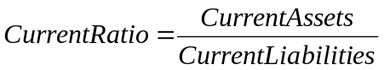

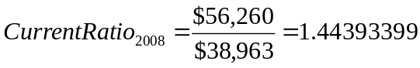

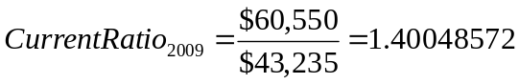

2008 2009
- Quick Ratio 0.8515 0.8303

The quick ratio is current assets minus inventory divided by current liabilities:

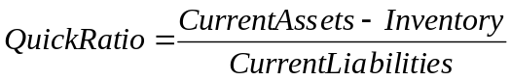

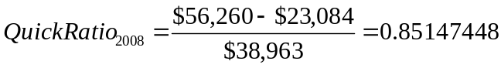

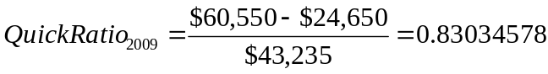

2008 2009
- Cash Ratio 0.5610 0.5100

The cash ratio is cash divided by current liabilities:

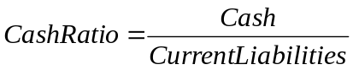

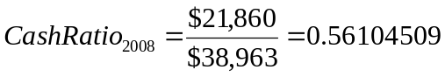

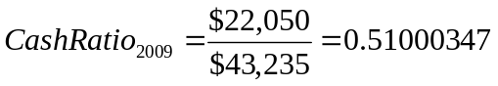
Asset Utilization Ratios:
2009
- Total Asset Turnover (TAT) 0.9525X

The TAT ratio is net sales divided by total assets:

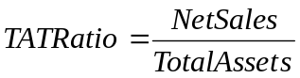

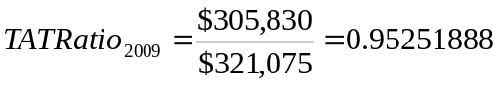

2009
- Inventory Turnover 8.5572X

The inventory turnover ratio is cost of goods sold divided by inventory:

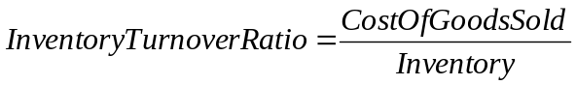

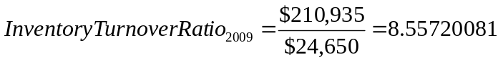

2009
- Accounts Receivables (A/R) Turnover 22.0816X

The A/R turnover ratio is net sales divided by accounts receivable:

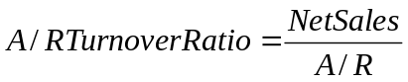

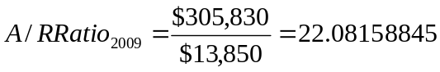

Long-Term Solvency Ratios:
2008 2009
- Total Debt Ratio 0.3925 0.3994

The total debt ratio is total debt (total assets minus total equity) divided by total assets:

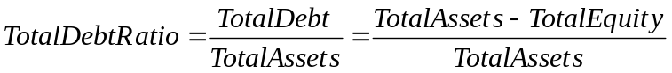

2008 2009
- Debt-Equity Ratio 0.6462 0.6650

The debt-equity ratio is total debt divided by total equity:

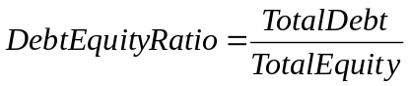

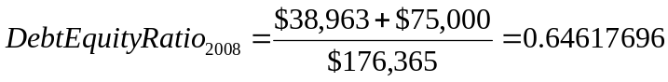

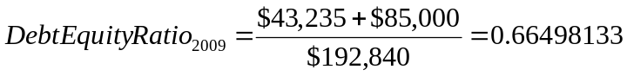

2008 2009
- Equity Multiplier Ratio 1.6462 1.6650

Leverage Multiplier Ratio 1.6462 1.6650

The equity multiplier ratio is 1 plus the debt-equity ratio:

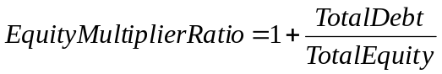

The leverage multiplier ratio is total assets divided by total equity:

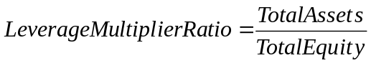

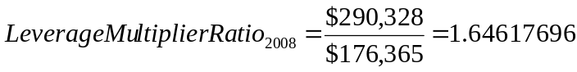

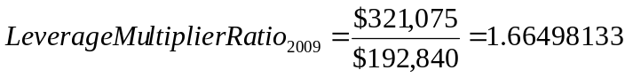

2009
- Times Interest Earned (TIE) Ratio 5.7037X

The TIE ratio is EBIT divided by interest:

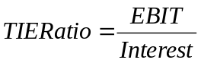

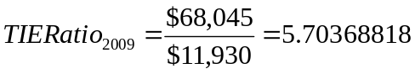

2009
- Cash Coverage Ratio 7.9543X

The cash coverage ratio is EBIT plus depreciation divided by interest:

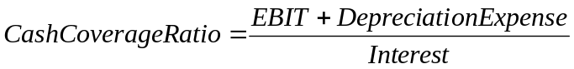

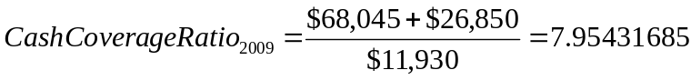

Profitability Ratios:
2009
- Net Profit Margin (NPM) Ratio 11.9266%

The NPM ratio is net income divided by net sales:

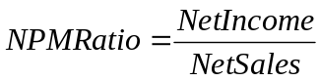

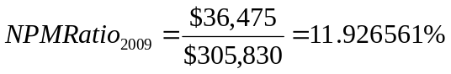

2009
- Return On Assets (ROA) 11.3603%

The ROA ratio is net income divided by total assets:

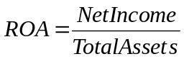

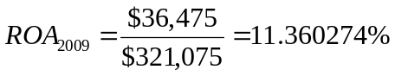

2009
- Return On Equity (ROE) 18.9146%

The ROE ratio is net income divided by total equity:

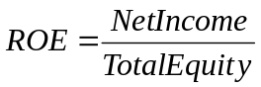

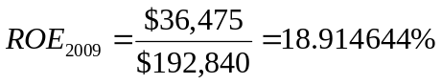

- DuPont Identity: Construct the DuPont identity for Smolira Gold Corp.

The DuPont identity is:

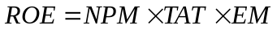

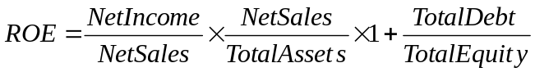

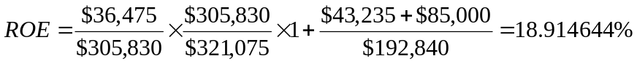

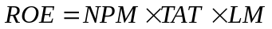

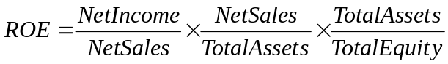

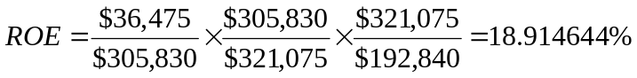
- Statement of Cash Flow: Prepare the 2009 statement of cash flows for Smolira Golf Corp.

SMOLIRA GOLF CORP.
2009 Statement of Cash Flows

Cash: Beginning of 2009¹ $ 21,860¹

Operating Activities
Net Income $ 36,475
Plus:
Depreciation 26,850
Increase in A/P² 3,530²
Increase in Other Current Liabilities³ 1,742³
Less:
Increase in A/R⁴ (2,534)⁴
Increase in Inventory⁵ (1,566)⁵
Net Cash from Operating Activities $ 64,497

Investment Activities
Fixed Asset Acquisition⁶ $(53,307)⁶
Net Cash from Investment Activities $(53,307)

Financing Activities
Decrease in Notes Payable⁷ $ (1,000)⁷
Dividends Paid (20,000)
Increase in Long-Term Debt⁸ 10,000⁸
Net Cash from Financing Activities $(11,000)

Net Increase (Decrease) in Cash $ 190

Cash: End of 2009⁹ $ 22,050⁹

¹Cash: Beginning of 2009 is the same as ending cash for 2008

²Increase in A/P:

³Increase in Other Current Liabilities:

⁴Increase in A/R:

⁵Increase in Inventory:

⁶Increase in Fixed Assets:

⁷Decrease in Notes Payable:

⁸Increase in Long-Term Debt:

⁹Cash: End of Year:

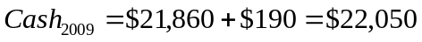

- Market Value Ratios: Smolira Golf Corp. has 25,000 shares of common stock outstanding, and the market price for a share of stock at the end of 2009 was $43. What is the price-earnings ratio? What are the dividends per share? What is the market-to-book ratio at the end of 2009? If the company’s growth is 9 percent, what is the PEG ratio?

The price-earnings (PE) ratio is:

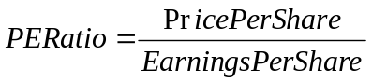

Earnings per share (EPS) are:

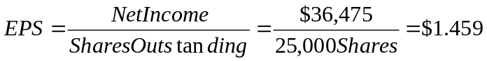

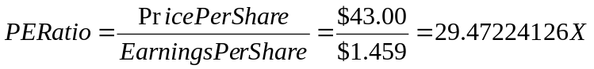

Dividends per share are:

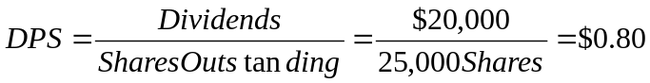

Market-to-Book ratio is:

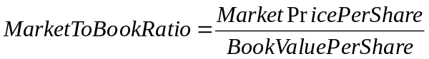

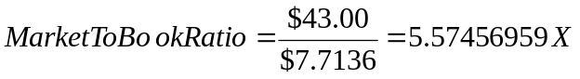

The PE-to-Growth (PEG) ratio is:

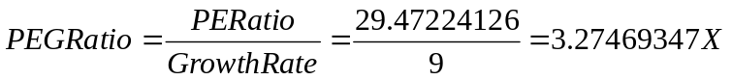

The PEG ratio is a valuation metric for determining the relative trade-off between the price of a stock, the earnings generated per share, and the company’s expected growth rate. Since the PE ratio is generally higher for a company with higher growth, dividing the PE ratio by the firm’s growth rate enables the evaluation of firm’s with different growth rates.

- Tobin’s Q: What is Tobin’s Q for Smolira Golf? What assumptions are you making about the book value of assets and the market value of assets? Are these assumptions realistic? Why or why not?

Tobin’s Q is:

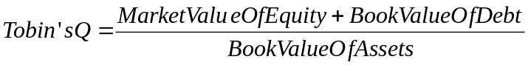

Market Value of Equity is:

Book Value of Debt is:

